Notification regarding the Board of Management’s annual review of the anti-bullying policy

To: Parents

The Board of Management of SN Ros Dumhach wishes to inform you that:

  - The Board of Management’s annual review of the school’s anti-bullying policy and its implementation was completed at the Board meeting of 13/06/2023[date].

  - This review was conducted in accordance with the checklist set out in Appendix 4 of the Department’s Anti-Bullying Procedures for Primary and Post-Primary Schools.

Signed 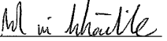 Date 13/06/2023
Chairperson, Board of Management

Signed 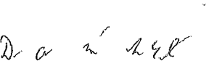 Date 13/06/2023
Principal

